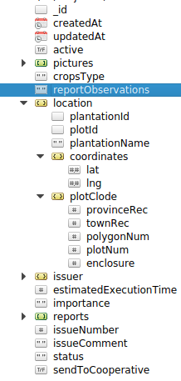
STATUS_CREATED
1

STATUS_PENDING_WORKORDER

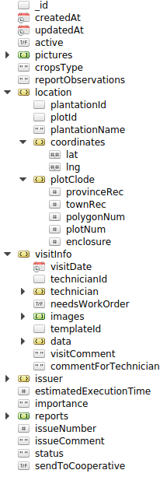
STATUS_PENDING_VISIT

3
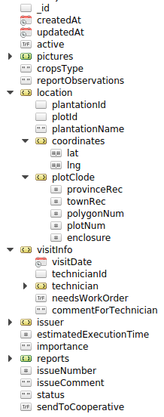
2

true
false

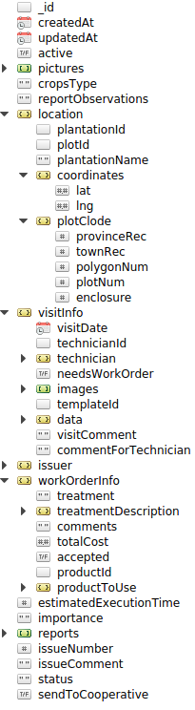
STATUS_WORK_ORDER
STATUS_ACEPTED
4
5
false
true

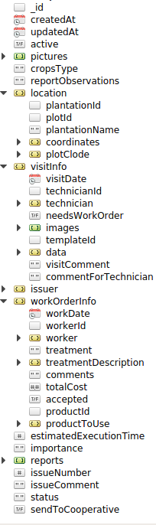
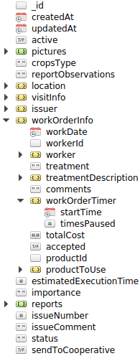
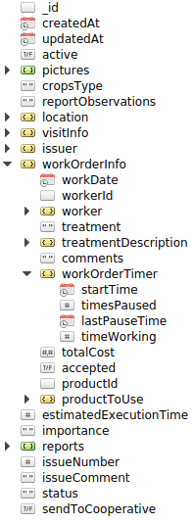
STATUS_ASSIGNED
6
6
7
STATUS_WORKING
STATUS_PAUSED && STATUS_FINISHED
8

